TI 23 – 06 Technology Example – Liquid Ring Compressors for Flare Gas Recovery
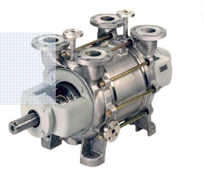 Example: Nash Liquid Ring Compressor

Liquid Ring Compressors
While there are many compressors available for flare gas applications, liquid ring compressors are attracting a lot of attention because of their design and reliability that make them ideal for use in aggressive environments.
One reason for the liquid ring compressors’ reliability is that it uses a liquid ring formed from the operating liquid, instead of a mechanical piston, as an energy carrier to compress gases and vapors. Liquid ring compressors can compress nearly all gases and vapors without any metallic parts contacting one another, which is advantageous because sliding parts are subject to vibration and wear, which impacts efficiency and leads to increased maintenance, downtime and possibly mechanical failure.
These compressors also use a double-shaft seal design, which creates a safer environment for the compression of flammable mixtures as well as toxic and environmentally hazardous materials. Liquid ring compressors use an impeller located within a cylindrical casing, which is filled with operating liquid (typically water). As the impeller rotates, the resulting centrifugal force forms a moving cylindrical ring against the inside wall of the casing.
This results in a volumetric expansion in the section of the outflowing liquid ring, which causes the medium to be drawn in via the inlet port in the guide plate. In the area of the inflowing liquid ring, the volume is reduced, causing the medium to be compressed. After compression, the medium is discharged via the outlet port in the guide plate.
Link to Vendors website for further information:
Enhance Flare Gas Recovery with Liquid Ring Compressors | Pumps & Systems (pumpsandsystems.com)

